# RFID Gin Data Management Install Guide

**Last updated**: 06/27/2018

**Version**: 1.0

**Prepared by:**

Bohn Technology Solutions, LLC

**Prepared for:**

United States Department of Agriculture, Agricultural Research Service

## Software License

*RFID Gin Data Management*, *RFID Truck Scan*, and *RFID Module Scan* and all associated documentation files, collectively the “Software”, are licensed under the following MIT license.

### The MIT License (MIT)

Copyright (c) 2018 United States Department of Agriculture, Agricultural Research Service

Permission is hereby granted, free of charge, to any person obtaining a copy of this software and associated documentation files (the "Software"), to deal in the Software without restriction, including without limitation the rights to use, copy, modify, merge, publish, distribute, sublicense, and/or sell copies of the Software, and to permit persons to whom the Software is furnished to do so, subject to the following conditions:

The above copyright notice and this permission notice shall be included in all copies or substantial portions of the Software.

THE SOFTWARE IS PROVIDED "AS IS", WITHOUT WARRANTY OF ANY KIND, EXPRESS OR IMPLIED, INCLUDING BUT NOT LIMITED TO THE WARRANTIES OF MERCHANTABILITY, FITNESS FOR A PARTICULAR PURPOSE AND NONINFRINGEMENT. IN NO EVENT SHALL THE AUTHORS OR COPYRIGHT HOLDERS BE LIABLE FOR ANY CLAIM, DAMAGES OR OTHER LIABILITY, WHETHER IN AN ACTION OF CONTRACT, TORT OR OTHERWISE, ARISING FROM, OUT OF OR IN CONNECTION WITH THE SOFTWARE OR THE USE OR OTHER DEALINGS IN THE SOFTWARE.

## Introduction

*RFID Gin Data Management* is an application that runs on a Windows 10 computer at the gin office. This application is capable of aggregating data from multiple input sources including:

* Modules scanned in the field using *RFID Module Scan*.
* John Deere Harvest ID Files (downloaded using the Cotton Harvest Data Utility or other software.)
* Data collected on module trucks running the *RFID Truck Scan* software.

**The *RFID Gin Data Management* software allows you to:**

* Manage master client, farm, and field lists.
* Manage master truck and driver lists.
* Create pickup lists and dispatch them to module trucks running the *RFID Truck Scan* software.
* Receive data from module trucks equipped with the *RFID Truck Scan* software and hardware.
* Track location history and status of modules from the field all the way to the gin feeder.
* Import module data files from an IMAP capable email account.
* Import data files on a schedule from a hard drive folder location.
* See a summary of modules and loads remaining in the field.
* Generate report files in CSV, HID, and PDF format.
* Plot module locations on a map.

**The *RFID Truck Scan* software performs the following functions:**

* Receives client, farm, field, and pickup lists posted to a *Microsoft Azure Cosmos* database hosted in the cloud.
* Aggregates data from GPS, RFID tags, and a shaft sensor to track the exact location where modules are loaded and unloaded.
* Automatically detects when modules are on the gin yard or have been dropped at the gin feeder using configured GPS boundary coordinates.
* Displays module locations on an in-cab display.
* Displays driving directions to the field using the Microsoft Maps application built into Windows 10.

## Pre-requisites

### RFID Gin Data Management Software

The *RFID Gin Data Management* software has the following system pre-requisites:

* Windows 10 operating system
* Reliable internet connection

### RFID Truck Scan Software

The *RFID Truck Scan* software has the following hardware and software pre-requisites:

* Windows 10 operating system
* Impinj Speedway Revolution R420 RFID Reader and antennas
* Ublox EVK-7P GPS receiver connected to PC using a [USB to Serial Port adapter](https://www.bestbuy.com/site/insignia-1-3-usb-to-rs-232-db9-pda-serial-adapter-cable-black/5883029.p?skuId=5883029) with a Prolific chipset.
* Shaft encoder connected to a US Digital Quadrature to USB Adapter ([QSB-D model](https://www.usdigital.com/products/interfaces/pc/usb/QSB))
* Nuvo 5100 VTC automotive PC equipped with 4G cellular modem
* Touch screen display

### Online Services Pre-requisites

To share data between the truck and gin software, a *Microsoft Azure Cosmos* database subscription is required. You must also obtain a Google Maps API key so that the system can plot module locations.

## Installation Steps Overview

To complete the system installation, you should perform steps in the following sequence:

1. Obtain GPS coordinates of your gin yard and feeder.
2. Setup Azure Cosmos database subscription (this will require a credit card as a payment method.)
3. Obtain a Google Maps API key (this will require a credit card as a payment method.)
4. Install the *RFID Gin Data Management* software.
5. Create truck and driver lists using the *RFID Gin Data Management* software.
6. Create the truck installer package on a removable USB drive in the gin software.
7. Install the truck software on each truck.
8. Optionally, connect the *RFID Module Scan* Android app.

The above steps will be covered in detail in subsequent sections.

## RFID Gin Data Management Setup Sheet

Use this sheet to record information that will be used during the software install.

|  |  |
| --- | --- |
| GIN YARD COORDINATES |  |
| Northwest corner latitude |  |
| Northwest corner longitude |  |
|  |  |
| Southeast corner latitude |  |
| Southeast corner longitude |  |

|  |  |
| --- | --- |
| GIN FEEDER COORDINATES (this is the point where modules are dropped at the feeder) | |
| Feeder latitude |  |
| Feeder longitude |  |

|  |  |
| --- | --- |
| EMAIL ACCOUNT (optional, this is an email account that receives files from RFID module scan) | |
| IMAP Hostname |  |
| IMAP Username |  |
| IMAP Password |  |
| IMAP Port (usually 993, but varies by provider) |  |

|  |  |
| --- | --- |
| AZURE COSMOS DATABASE READ/WRITE SETTINGS | |
| URI |  |
| KEY |  |

|  |  |
| --- | --- |
| AZURE COSMOS DATABASE READ ONLY SETTINGS | |
| URI |  |
| KEY |  |

|  |  |
| --- | --- |
| GOOGLE MAPS API KEY | |
| KEY |  |

## Obtain Gin Yard Coordinates

The system uses a geo-coded rectangle to represent the gin yard, and a single point and circular radius to identify the feeder drop zone. The feeder drop zone may fall inside the defined yard rectangle. You can use a software tool such as Google Earth or a hand-held GPS to find these coordinates. You need to obtain and record the following coordinates. **All coordinates should be in decimal degrees.**

* Latitude and longitude of northwest corner of the gin yard
* Latitude and longitude of southwest corner of the gin yard
* Latitude and longitude of feeder drop point.

As you obtain these coordinates, add them to the RFID Gin Data Management Setup Sheet.

## Setup Azure Subscription

### Step 1

Go to <https://azure.microsoft.com/en-us/pricing/purchase-options/> and click the *Purchase Now* button as illustrated below:

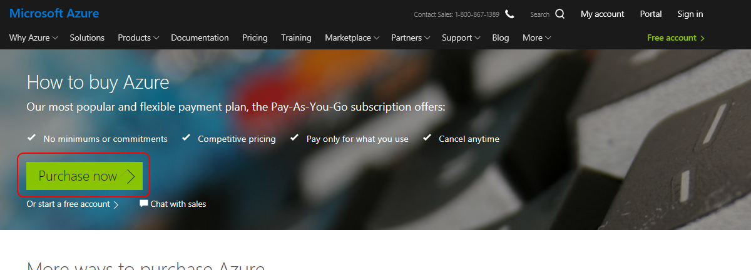

### Step 2

You will be presented with a sign-in screen. If you already have a Microsoft account, you may sign-in. This manual assumes you do not. To create an account, click the *Create one!* link.

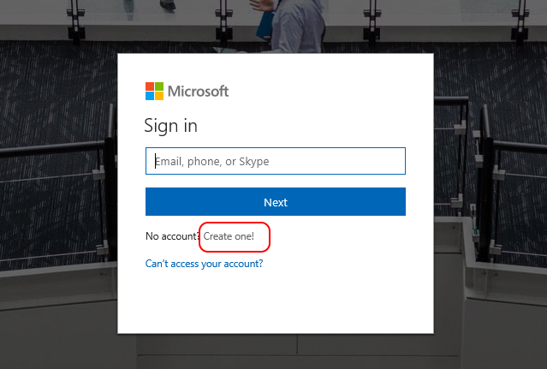

### Step 3 – Enter Email Address

Enter your email address on the *Create account* screen. Click *Next* and enter a password, then click *Next* again.

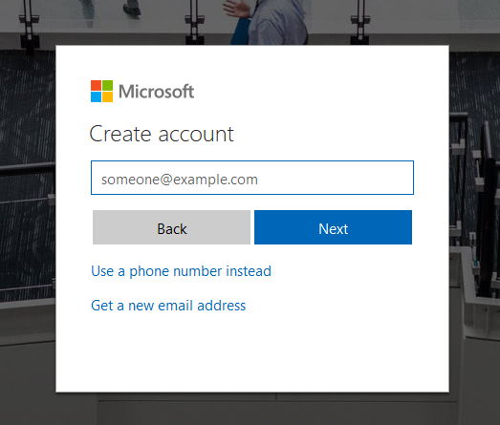

### Step 4 – Verify Email Address

Enter the verification code you received in your email on the *Verify email* screen and click *Next*.

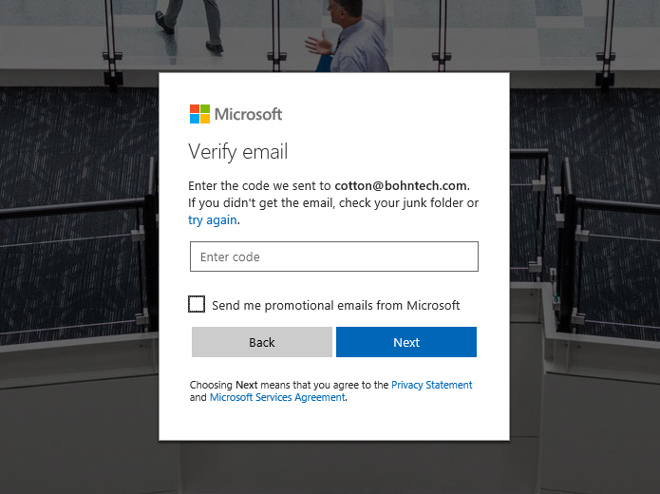

### Step 5 – Image verification

If you are presented with an image to verify that you are a real person, then type the text code from the image in the box and click *Next*.

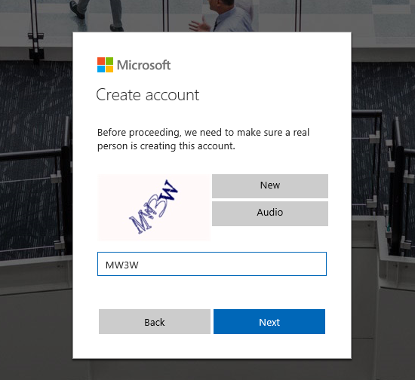

### Step 6 – Compete About You Section

When presented with the form below, complete all information and click *Next.*

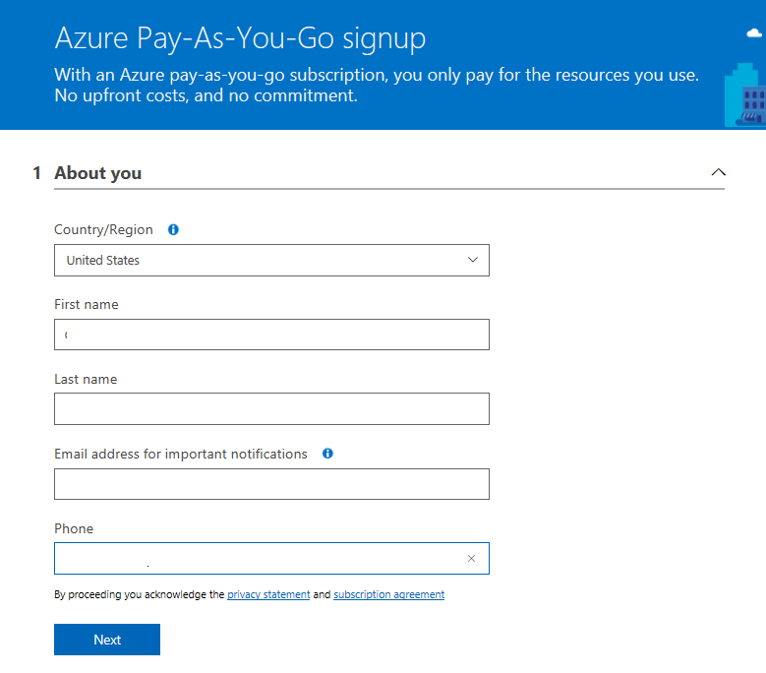

### Step 7 – Complete Phone Verification

Enter a valid phone number then choose either *Text me* or *Call me*. You will receive a verification code either by text or phone call within a few minutes. Enter the received code when prompted.

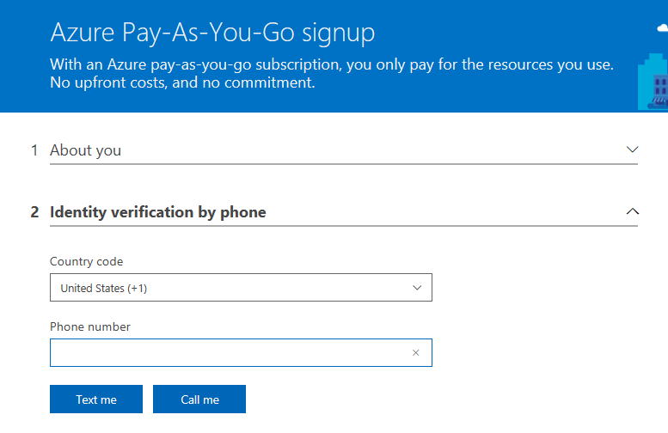

### Step 8 – Enter Payment details

In the payment information section, enter your credit card information and click *Next*.

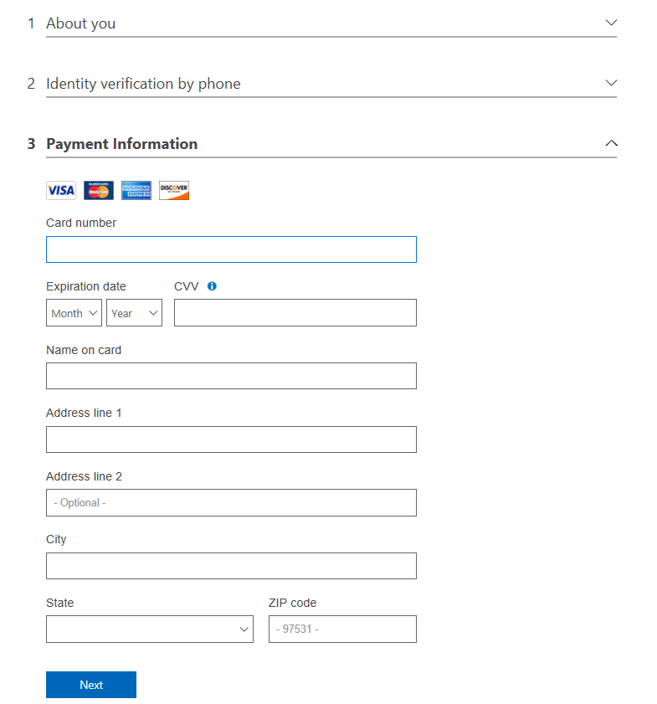

### Step 9 – Tech Support Options

When presented with Microsoft Tech Support options, choose the *No technical support* option as illustrated below. Microsoft support would only provide support for Azure services, not the *RFID Gin Data Management* software.

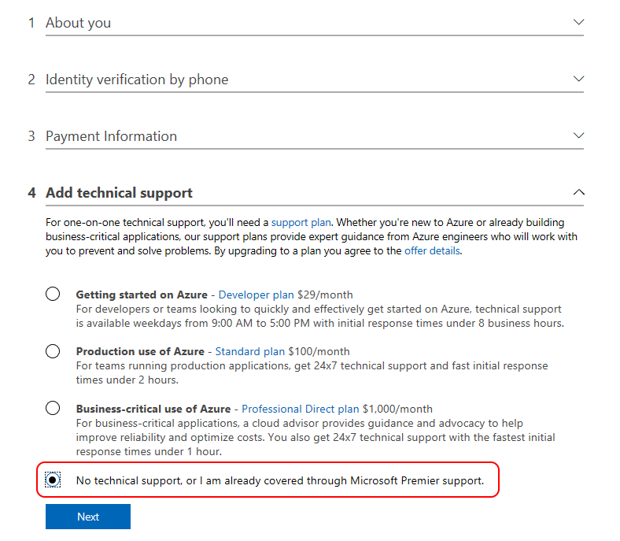

### Step 10 – Agree to Terms of Service

To complete your Azure account setup, review the terms and click *Sign up*.

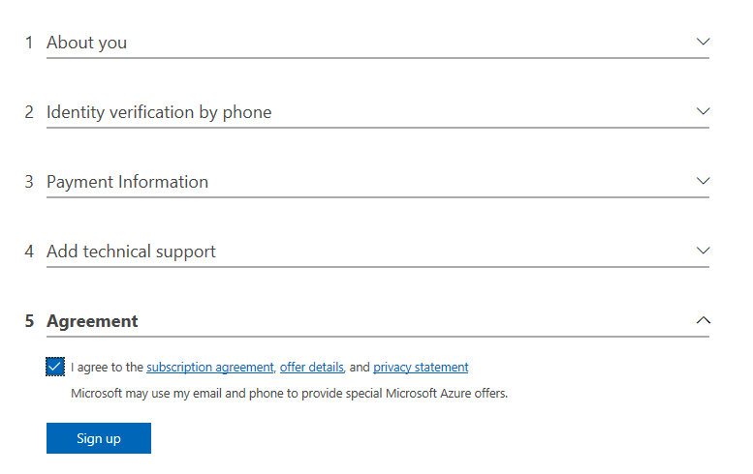

Next, you will see a screen like the following. Click the green *Go to portal* button, and continue with the next section of this document: *Setting up Azure Cosmos DB.*

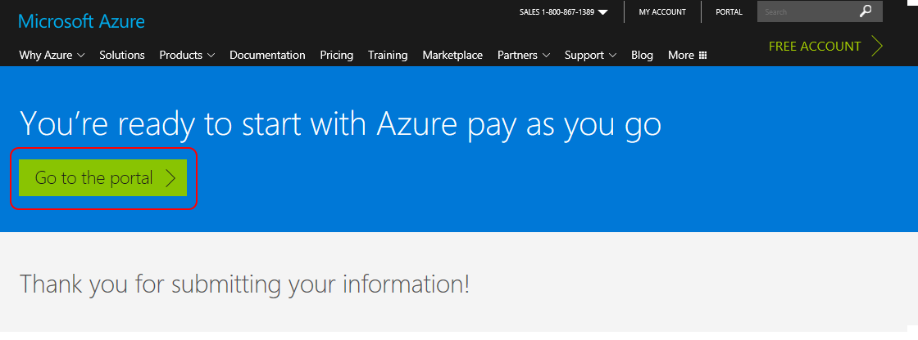

## Setting up Azure Cosmos DB

### Step 1 – Sign into the Azure portal

If not already signed in, go to <https://portal.azure.com/> and sign in with your Microsoft account. If presented with a Welcome message as shown below, click *Maybe later* to clear the message.

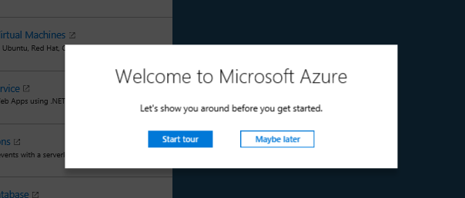

### Step 2 – Navigate to Azure Cosmos DB

From the Azure portal dashboard, click *Azure Cosmos DB*, in the left-hand menu as shown below:

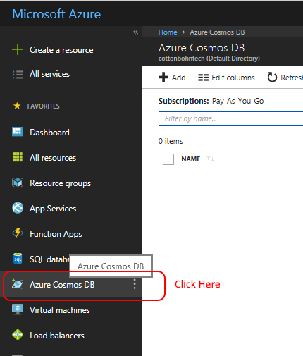

### Step 3 – Create Cosmos DB

From the Cosmos DB page click the *Add* link in the upper left corner as shown below:

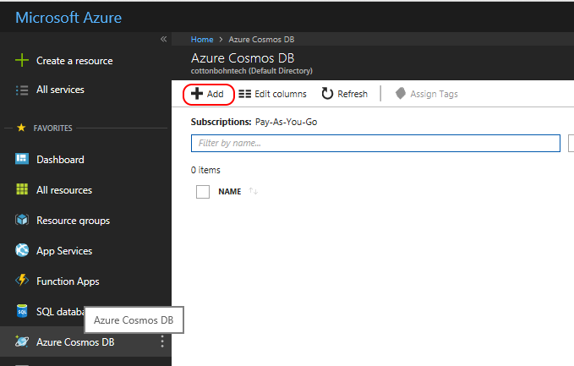

A form will appear on the right side of the screen as shown below: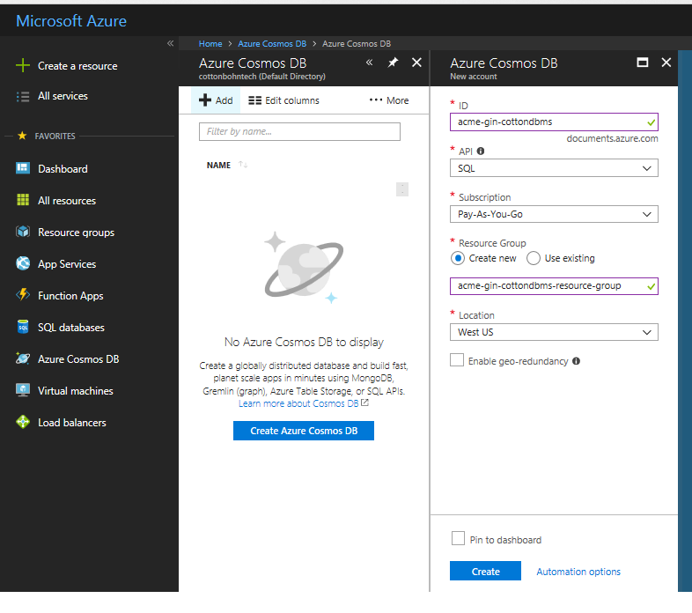

Complete the fields as follows:

* **ID** – Enter a unique ID for the database. We recommend using the format *organization-name*-cottondbms. Where *organization-name,* is your organization name.
* **API** – Select SQL – **IMPORTANT!! If the wrong API is chosen the software cannot communicate with the database**
* **Subscription** – select your pay-as-you-go subscription.
* **Resource Group** - Choose *Create new* and enter a unique name. We recommend using the name *organization-name*-cottondbms-resource-group. Where *organization-name,* is your organization name.
* **Location** - choose *West US*
* Uncheck *Enable geo-redundancy*
* Finally, click *Create*

### Step 4 – Copy Database URL and Keys

After creating the database, click the *Refresh* button at the top of the Azure Cosmos DB page. Your newly created database should appear in the list after a few minutes. Once it appears in the list, click the link for your database in the *NAME* column.

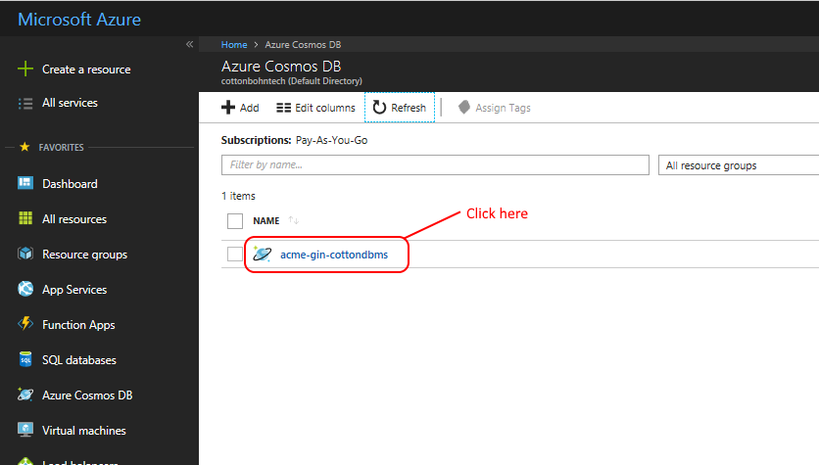

On the subsequent screen. Click the *Keys* item in the sub-menu.

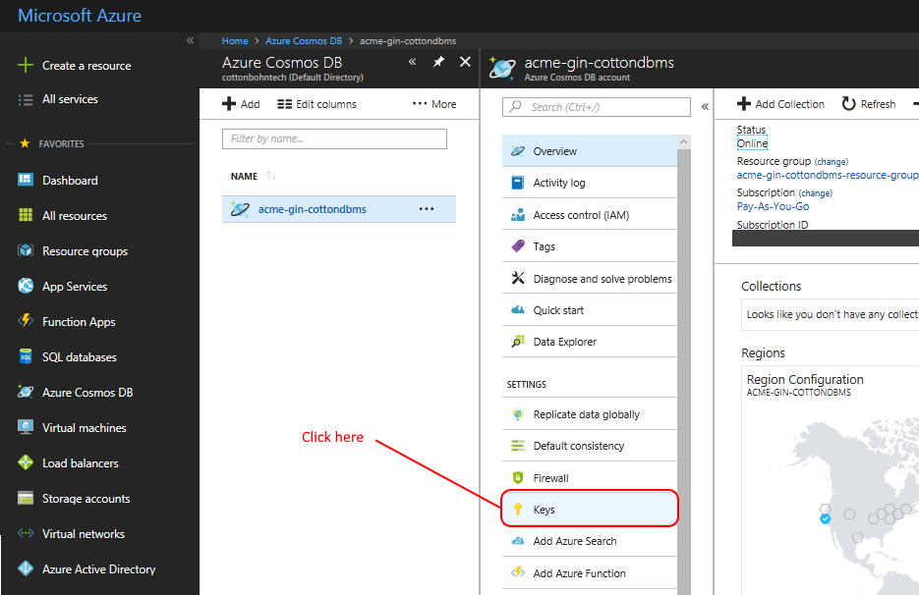

* The screen will show a tabbed view on the right.
* Copy the *URI* *and Primary key* (circled in red below) and paste them as the read/write settings in the RFID Gin Data Management Setup Sheet. Please note, that these two pieces of information should be kept secure and only entered into the Gin application software and truck clients as they allow read-write access to your Azure Cosmos database.
* Click the *Read-only* keys tab and repeat this process by copying and pasting the Read-only *URI* and *Primary key* into the RFID Gin Data Management Setup Sheet.

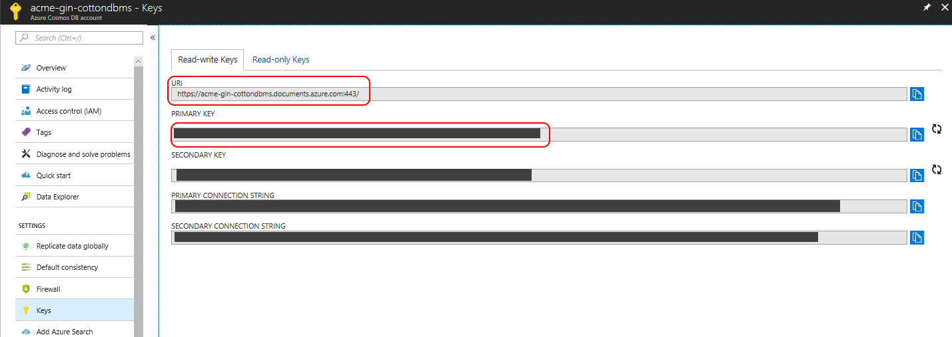

## Obtaining a Google Maps API Key

1. If you do not have a Google account, go to <https://accounts.google.com/SignUp?hl=en> to create an account.
2. Go to <https://developers.google.com/maps/documentation/javascript/get-api-key>
3. Click *GET A KEY*
4. You will see a screen like the one below. Check *Maps* and click *Continue.*

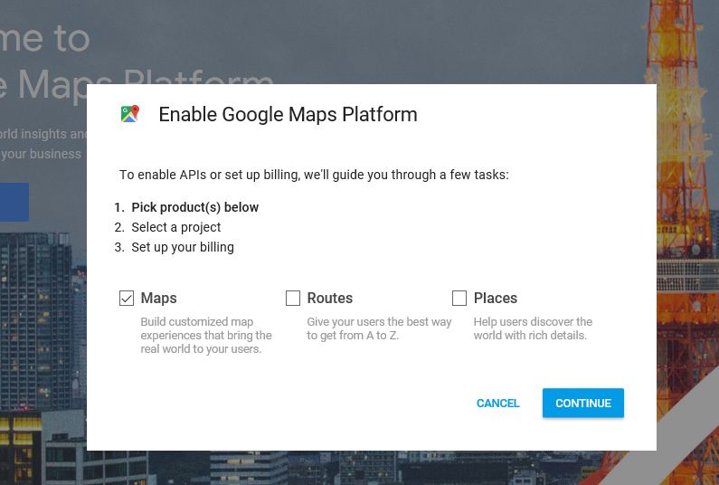

1. On the next screen, enter the name of your project and click *Next*. For example, use a project name such as *RFID Gin Database Maps*.

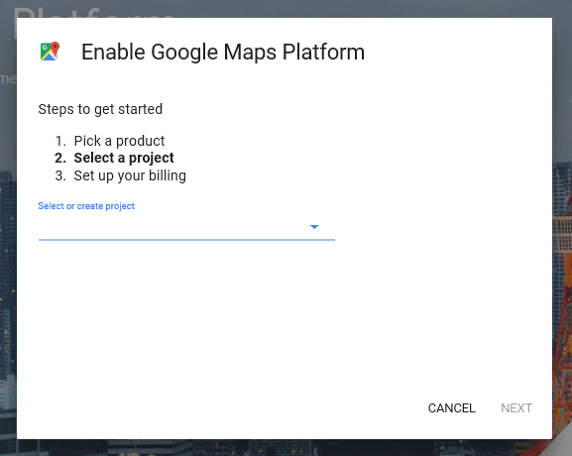

1. Next you will be prompted to create a billing account. Click *Create Billing Account*.

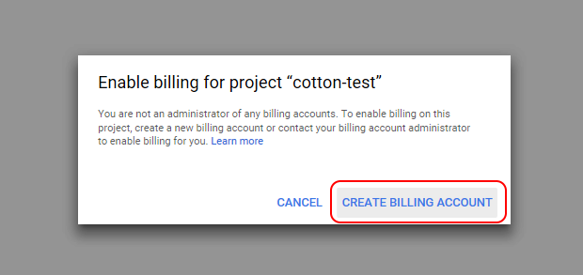

1. You will need to review the Terms of Service and click *Agree and continue*

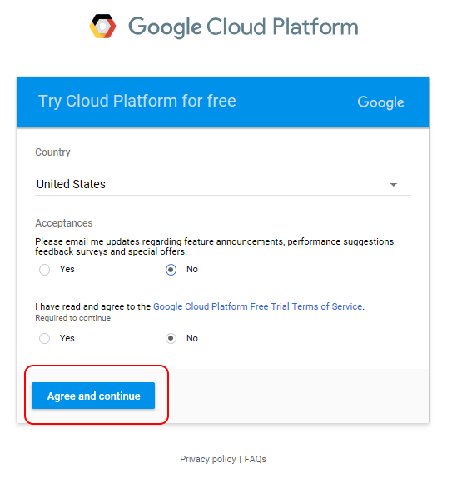

1. Next, complete the payments profile form and click *Start my Free Trial*.

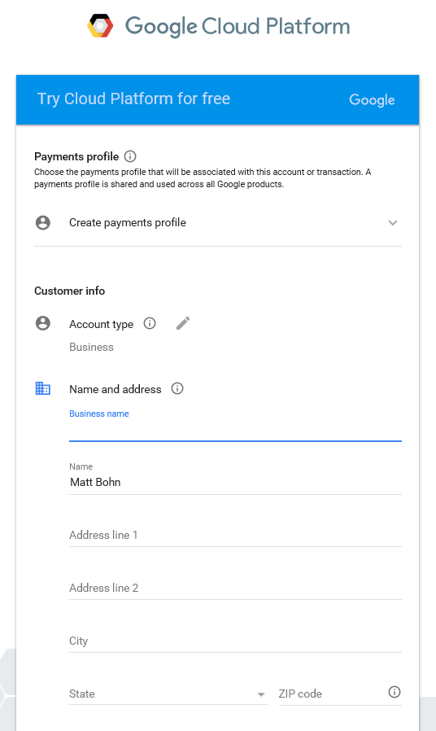

1. You will see a window, prompting you to “Enable Google Maps Platform”. Click *Next*.

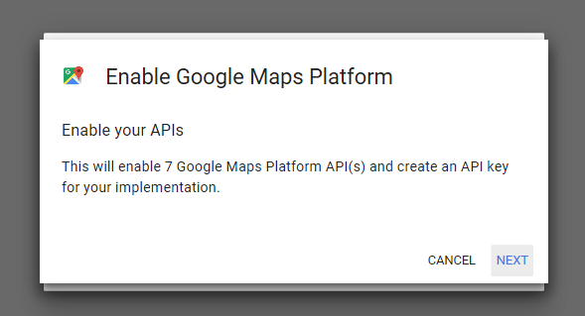

1. It may take some time, but you should see the following box after your project is created. Copy the API key and paste it in the RFID Gin Data Management Setup sheet. You will need this key during the gin software install process.

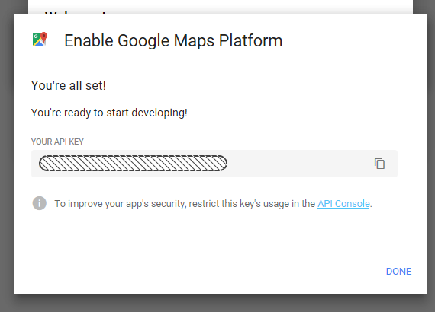

1. Once, you have copied the key click *DONE*.
2. To ensure that there are no interruptions in your Google Services, it is recommended that you upgrade your account from the free account. You should see an *Upgrade* button in the upper right corner of your browser. Click it to upgrade to a paid account.

## Install RFID Gin Data Management

The *RFID Gin Data Management* software is installed running a self-extracting setup application on a single gin computer. The setup will automatically download the .NET Framework 4.6.2 and Microsoft SQL Server Express Local DB 2014 pre-requisites.

**Note: Only one instance of the RFID Gin Data Management application should be installed.**

### Step 1 - Download and Extract the software

Download the installer this link https://github.com/bohntech/RFIDGinDataManagement/blob/master/Installer.zip.

Right click on the zip file and choose *Extract All*.

### Step 2 – Run the Setup application

* Open the folder where you extracted the ZIP file. You should see the following two files:

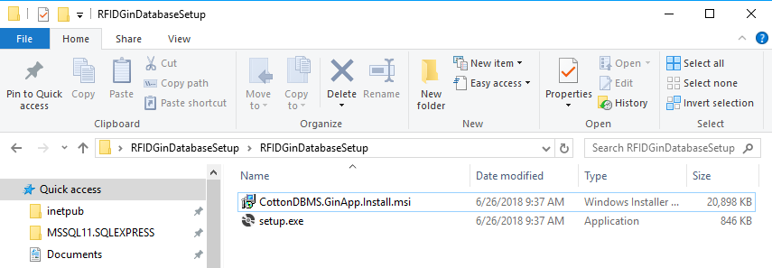

* Double click the *setup.exe* file to launch the setup application and proceed through the setup wizard.
* On the last step, choose *Launch RFID Gin Data Management* and click *Close*. The *RFID Gin Data Management* application will open and walk you through a step-by-step wizard to configure the system.
* To complete the wizard, you should have the information in the RFID Gin Data Management Setup Sheet completed and available for copy and paste into the appropriate steps.
* Once the wizard is completed, the application will load, and you should see the *Home* screen showing the *System Summary*.

### Step 3 – Enter Trucks

Before installing the truck software, you must add at least one truck to the system. To do so click the *Trucks* tab, and then click the *Add Truck* button as illustrated below:

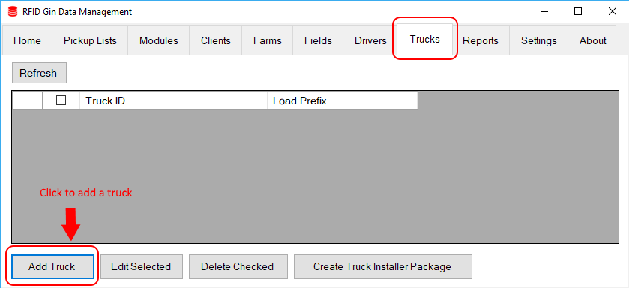

In the *Add Truck* window, enter a *Truck ID* and *Load Prefix* then click *Save*. All load numbers generated by this truck will be prefixed with the load prefix.

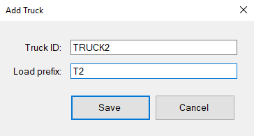

Repeat these steps to add a record for every truck that will have the *RFID Truck Scan* software installed.

### Step 4 – Enter Drivers

Navigate to the *Drivers* tab and click the *Add Driver* button to add at least one driver to the system. Repeat this to add all drivers that will be using the system.

### Step 5 – Create Truck Install Package

* Insert a USB drive into an available USB port on the Gin computer.
* Click on the *Trucks* tab.
* Click *Create Truck Installer Package* at the bottom of the screen.
* A dialog box will appear listing all removable drives attached to the computer.
* Select the target USB removable drive.
* Click *Create Package.*
* You should see a message, indicating the files have been written to the drive after a few seconds.

### Step 6 – Sync Gin Software to Cloud

Return to the *Home* tab and click the *Run Data Sync* button. This will ensure that the trucks, drivers, and other needed settings are written to the cloud database and will be available to trucks.

At this point you may continue by installing the truck software on each truck.

## Install RFID Truck Scan

### Hardware Setup

Before installing the *RFID Truck Scan* software on a truck computer, the following hardware should be installed and connected:

* GPS unit connected via USB to serial adapter
* Impinj Speedway RFID reader connected using *PoE*
* Shaft encoder and USB adapter connected to USB port
* Touch display connected to DVI or VGA port
* It is recommended that Windows update be run using a Wi-Fi connection after all hardware is connected to ensure latest drivers are installed.

### Download Offline Maps

To have navigation information available offline, it is recommended that you download the relevant offline Maps by following the instructions in this Microsoft Maps support [article](https://support.microsoft.com/en-us/help/4027402/windows-download-maps). You should download maps for your state or area for offline use.

### Run Install Package

1. Power on the truck computer system.
2. **Ensure that the system has a network connection to the internet.**
3. Insert the removable USB drive containing the truck installer package created by the *RFID Gin Data Management* application.
4. Run the *setup.exe* file saved in the root folder of the USB drive.
5. Proceed through the installer.
6. On the last step, ensure *Launch RFID Truck Scan* is checked and then click *Close.*

### Complete Initial Configuration

When *RFID Truck Scan* runs the first time, it will walk you through choosing the initial settings needed.

* Select a truck and driver and click *Continue*

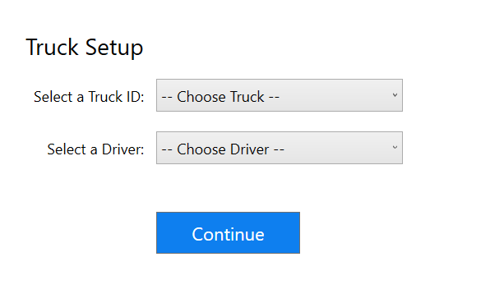

IMPORTANT! EACH TRUCK MUST BE ASSIGNED A UNIQUE TRUCK ID.

* Set a password to protect your database keys, reader settings, and truck id assignment. This is not required but is highly recommended.

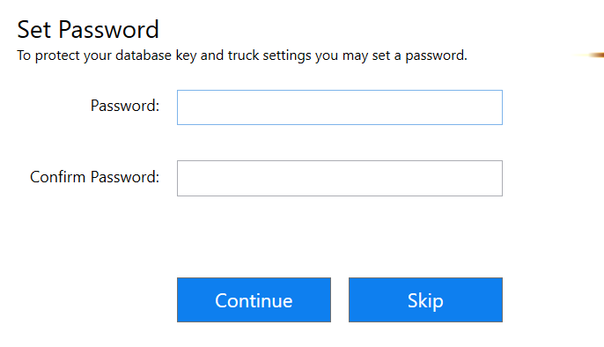

* After setting the password, the system should start by locating the reader, shaft sensor, and GPS sensor.

## Connect RFID Module Scan

*RFID Cotton Module Scan* is an Android application that can be used to scan modules in the field. Modules can be scanned into a load list which may be transmitted to the gin. This app can run in independent mode or gin mode. When running in gin mode, the application can read client, farm, and field master lists managed by the *RFID Gin Data Management* software.

To use *RFID Module Scan* in *GIN* mode, follow these steps:

* First, ensure you have the latest version *of RFID Module Scan* installed.
* In the *RFID Gin Data Management* application, go to the *Settings* tab
* In the box labeled *Azure Cosmos READ ONLY Keys* click the *Connect RFID Module Scan* button. A window should appear displaying a QR code. You need to scan this code from *RFID Module Scan*.
* Open *RFID Module Scan* on your Android device and go to *Settings*
* Scroll to the bottom of the *Settings* screen and tap *Connect to Gin*
* A camera view will open. Hold your device up to the 2D bar code to scan it.
* The camera view will automatically close, and you should see *Connected to: [your gin name]* at the bottom of the Android app settings screen.